
TEACHERS SERVICE COMMISSION
HIGHLIGHTS OF THE PROPOSED
REVISED CAREER
PROGRESSION GUIDELINES
(
CPG)
FOR TEACHERS
AND CURRICULUM SUPPORT OFFICERS
9
TH
JUNE, 2026
ESTABLISHMENT OF TSC
❖Established under Article 237 of the Constitution of Kenya, 2010.
❖Granted the dual mandate- Teacher Management & Regulation of the Teaching Service.

TEACHER MANAGEMENT MANDATE
Article 237(2) of the Constitution:
i. Recruit and employ registered teachers ii. Assign teachers for service iii. Promote and transfer teachers iv. Exercise disciplinary control
v. Terminate employment of teachers

REGULATORY MANDATE
Article 237 (2) (a)(3) of the Constitution:
i. Review standards of education and teacher training ii. Review demand and supply of teachers
iii. Advise the national government on matters relating to the teaching profession

TEACHERS SERVICE COMMISSION ACT
➢Operationalize the mandate of the TSC under Article 237.
➢Section 11 additional functions-
- Facilitate career progression and professional development for teachers
- Ensure compliance with teaching standards,
- Monitor the conduct and performance of teachers in the teaching service.

JUSTIFICATION FOR REVIEW OF CPG

•
The
implementation
of
the
CBE
•
Address
challenges
with
the
Grading
Structure
;
•
Precursor
for
Job
Evaluation
•
Implement
feedback
from
teachers
•
Need
to
separate
administrative
positions
from
professional
tasks
WHY WE ARE HERE

•
A
constitutional
imperative
for
public
participation
-
Article
10
•
Commission’s
directive
on
stakeholder
engagement
.
•
A
statutory
requirement
under
the
2025
-
2029
CBA

-THE END-

BACKGROUND ON THE CPG 2018
The Commission participated in the Job Evaluation for the 2016 cycle during which the
following were the results and the mapping of the JE results against the TSC Scales for
Teachers and CSOs;
JOB DESIGNATIONS/JOB TITLE
LAST JOB EVALUATION
GRADE
INSTITUTIONS JOB GRADE/
GROUP
Chief Principal
D5
T
-
Scale 15
Senior Principal
D4
T
-
Scale 14
Principal
D3
T
-
Scale 13
Deputy Principal I
Deputy Principal II
D2
T
-
Scale 12
Senior Master I
Senior Lecturer I
Senior Master II
D1
T
-
Scale 11
Deputy Principal III
Senior Head teacher
Senior Lecturer II
Curriculum Support Officer I

BACKGROUND ON THE CPG 2018
JOB DESIGNATIONS/JOB TITLE
LAST JOB EVALUATION GRADE
INSTITUTIONS JOB
GRADE/ GROUP
Senior Master III
C5
T
-
Scale 10
Senior Lecturer III
Head teacher
Deputy Head teacher I
Curriculum Support Officer II
Senior Master IV
C4
T Scale 9
Senior Lecturer IV
Deputy Head teacher II
Secondary Teacher I
C3
T
-
Scale 8
Lecturer I
Senior Teacher I

BACKGROUND ON THE CPG 2018
JOB DESIGNATIONS/JOB TITLE
LAST JOB EVALUATION GRADE
INSTITUTIONS JOB
GRADE/ GROUP
Secondary Teacher II
C2
T
-
Scale 7
Lecturer II
Senior Teacher II
Secondary Teacher III
C1
T
-
Scale 6
Lecturer III
Primary Teacher I
Primary Teacher II
B5
T
-
Scale 5
CHALLENGES WITH THE IMPLEMENTATION OF CPG 2018
➢
Disparities in remuneration for teachers, administrators and
curriculum support officers’ cadres.
➢
Categorization of Schools and aligning them to the
Remuneration Structure for Teachers
➢
Disparity in treatment of teachers with similar qualifications
➢
Taller scale structure thus pushing for longer period
requirement for growth.
➢
Combining professional as well as administrative work.
SUMMARY OF PROPOSED LEVELS
S/NO
CATEGORY
CURRENT LEVELS
PROPOSED LEVELS
1
Primary
-
Regular
8
6
2
Primary
-
SNE
5
5
3
Junior and Senior School
9
7
4
Secondary
-
SNE
9
6
5
Teacher Training Colleges
10
7
6
KISE And KIB
7
6
7
Curriculum Support Officers
-
Regular
4
3
8
Curriculum Support Officers
-
SNE
4
3
Totals
56
43
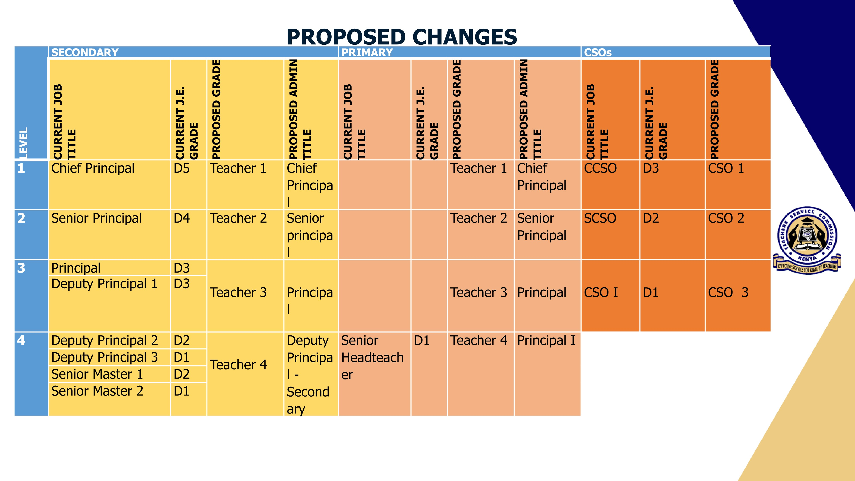
PROPOSED CHANGES
LEVEL
SECONDARY
PRIMARY
CURRENT JOB
TITLE
CURRENT J.E.
GRADE
PROPOSED GRADE
PROPOSED ADMIN
TITLE
CURRENT JOB
TITLE
CURRENT J.E.
GRADE
PROPOSED GRADE
PROPOSED ADMIN
TITLE
5
Senior Master 3
C5
Teacher
5
Senior
Teacher
-
Secondary
Headteacher
C5
Teacher 5
Principal II
Deputy
Headteacher 1
Senior Master 4
C4
Deputy
Headteacher 2
C4
Teacher 6
Deputy
Principal
-
Primary
PROPOSED CHANGES
LEVEL | SECONDARY |  |  |  | PRIMARY
LEVEL | CURRENT JOB  TITLE | CURRENT J.E.  GRADE | PROPOSED  GRADE | PROPOSED  ADMIN TITLE | CURRENT JOB  TITLE | CURRENT J.E.  GRADE | PROPOSED  GRADE | PROPOSED  ADMIN TITLE
6 | Secondary  Teacher 1 | C3 | Teacher 6 |  | Senior Teacher 1 | C3 | Teacher 7 | Senior  Teacher-  Primary
7 | Secondary  Teacher 2 | C2 | Teacher 7  (Degree) |  | Senior Teacher 2 | C2 | Teacher 7 | Senior  Teacher-  Primary
8 | Secondary  Teacher 3 | C1 | Teacher 8  (Diploma) |  | Primary Teacher 1 | C1 | Teacher 8  (Diploma)
9 |  |  |  |  | Primary Teacher 2 | B5 | Teacher 9  (PTEC)
PROPOSED CHANGES PRIMARY (REGULAR)
Designation | TSC  Grade | Administrative Positions | Classroom growth | Remarks
Teacher 9 | PT 9 | Entry grade for PTE Certificate holders | Primary teacher 9 | Entry for PTE certificate holders
Teacher 8 | PT 8 | Entry grade Diploma holders | Primary teacher 8 | Entry for Diploma / common cadre for  PTE
Teacher 7 | PT 7 | Senior Teacher -Primary | Primary teacher 7 | Common cadre for Diploma
Teacher 6 | PT 6 | Deputy Principal | Primary teacher 6 | Competitive
Teacher 5 | PT 5 | Principal 2- Primary | Primary teacher 5 | Competitive
Teacher 4 | PT 4 | Principal 1- Primary | Primary teacher 4 | Competitive
Teacher 3 | PT 3 | Principal | Primary teacher 3 | Competitive
Teacher 2 | PT 2 | Senior Principal | Primary teacher 2 | Competitive
Teacher 1 | PT 1 | Chief Principal | Primary teacher 1 | Competitive
Designation | TSC  Grade | Administrative Positions | Classroom growth | Remarks
Teacher 8  Secondary 3 | ST 8 | Entry grade for Diploma in  Education | Teacher 8
Teacher 7  Secondary 2 | ST 7 | Entry for Bachelor’s Degree | Teacher 7 | Common Cadre for  Diploma in Education
Teacher 6  Secondary 1 | ST 6 | Common cadre for Bachelor’s  Degree | Teacher 6 | Common cadre for  Bachelor’s Degree
Teacher 5  Secondary | ST 5 | Senior Teacher  -  Secondary | Teacher 5 | Competitive
Teacher 4  Secondary | ST 4 | Deputy Principal -Secondary | Teacher 4 | Competitive
Teacher 3  Secondary | ST 3 | Principal -Secondary | Teacher 3 | Competitive
Teacher 2  Secondary | ST 2 | Senior Principal -Secondary | Teacher 2 | Competitive
Teacher I  Secondary | ST 1 | Chief Principal -Secondary | Teacher 1 | Competitive
PROPOSED CHANGES SECONDARY (REGULAR)
PROPOSED CHANGES TTC
Substantive  Designation | TSC  Grade | Administrative Position | Classroom growth | Remarks
Teacher 7  TTC | TTC 7 | Entry grade (degree new  CBE specialized areas) | Teacher 7
Teacher 6  TTC | TTC 6 | Common Cadre for Degree holders | Teacher 6 | Common cadre for  Degree holders
Teacher 5  TTC | TTC 5 | Entry grade for Teacher 5  Secondary | Teacher 5 | Equivalence for  Secondary teacher 5
Teacher 4  TTC | TTC 4 | Senior Teacher TTC | Teacher 4 | Competitive
Teacher 3  TTC | TTC 3 | Principal Teacher TTC | Teacher 3 | Competitive
Teacher 2  TTC | TTC 2 | Deputy Principal TTC | Teacher 2 | Competitive
Teacher 1  TTC | TTC 1 | Chief Principal TTC | Teacher 1 | Competitive
PROPOSED CHANGES KISE

Designation
TSC
Grade
Administrative Position
Classroom growth
Remarks
Teacher 6
KISE
KISE 6
Entry grade for graduate
Teacher 6
Enty
Teacher 5
KISE
KISE 5
Common cadre promotional
grade for KISE 6
Teacher
5
Common
cadre
Teacher 4
KISE
KISE 4
Senior Teacher
–
KISE
Teacher
4
Competitive
Teacher 3
KISE
KISE 3
Principal Teacher
-
KISE
Teacher
3
Competitive
Teacher 2
KISE
KISE 2
Deputy Director
Teacher
2
Competitive
Teacher 1
KISE
KISE 1
Director
Teacher
1
Competitive
WAY FORWARD AFTER APPROVAL OF CPG
S/N O | ACTIVITY | ACTOR
1. | Submission of the approved CPG together with Job  Descriptions to the salaries and remuneration  Commission for Job Evaluation | TSC
2 | Conducting of Job Evaluation | SRC/TSC
3. | Conduct clinic on the JE results | SRC/TSC
4 | Communication of JE results and attendant financial implication to TSC | SRC/ NT
5 | Publishing of the JE results to teachers | TSC




